**ST. XAVIER’S COLLEGE**

**(Affiliated to Tribhuvan University)**

Maitighar, Kathmandu



**Data Base Management System Theory Assignment#4**

**Submitted by:**

Suraj Nepal

013BSCCSIT042

**Submitted to:**

|  |  |
| --- | --- |
| Er.Sanjay Kumar Yadav  Lecturer, St. Xavier’s College |  |

**Date of Submission:** Monday, August 10, 2015

ER diagram with one-case study:

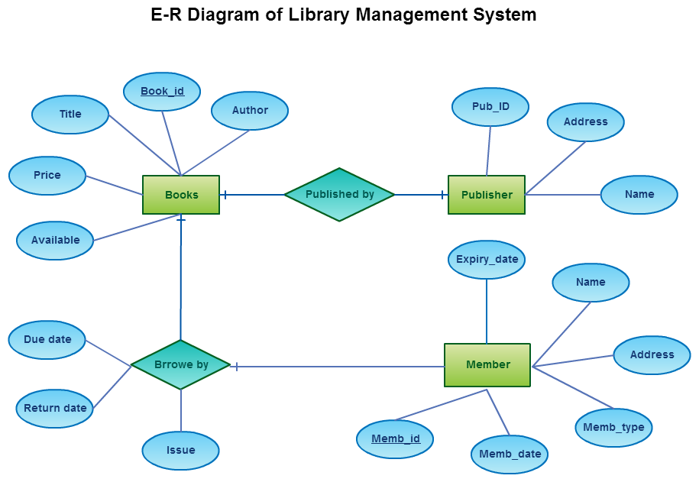

Database Design Phase

**(a)user specification requirements**

In the initial phase of database design, database designer need to characterize what data needs for database users and how the database is structured to fulfill these requirements. Database designer needs to interact with domain experts and users to carry out this task.

**(b)Conceptual design**

In this phase, database designer need to choose appropriate data model to translate the requirement into conceptual schema of the database. The conceptual design describes detail overview of enterprise. E-R model can be use to develop conceptual schema. In terms of E-R model, conceptual schema specifies all entity sets, relationship sets, attributes, and mapping constraints. Conceptual schema is also able to describe functional requirements of the enterprise. In functional requirements user can describes kind of operations that will be perform on data.

**(c)Logical design phase:**

In this phase database designer need to maps the high level conceptual schema onto the implementation data model of the database system.

**(d)Physical design phase**

In this phase, database designer specifies physical features of the database. These features include form of file organization and storage structure.

**Entity-Relationship Model**

**Entity-Relationship Model**

The selection of primary key in relationship set depends up on mapping cardinality of that relationship set. To illustrate this, let us consider entity sets customer and account, and relationship set depositor with declarative attribute access_date. Suppose that relationship set is many to many. Then primary key of depositor relationship set is combination of primary keys of customer and account. If customer can have only one account, that is, if relationship set is many to one from customer to account the primary key of depositor is simply primary key of customer (i.e customer_id). Similarly, if each account is own by at most one customer, that is, relationship set is many to one from account to customer then primary key of depositor is simply the primary key of account (i.e. account_id). If relationship set is one to one then we can choose either customer_id or account_id as primary key.

For non-binary relationship set where no cardinality constraints are define then superkey is only one possible candidate key. So it needs to be chosen as a primary key.

**One-to-one relationship representation**



Figure: one to one relationship set in E-R Diagram

This indicates a customer is associated with at most one loan via the relationship borrower and a loan is associated with at most one customer via borrower.

**One to many relationship representation**



Fig: This indicates a loan is associated with at most one customer via borrower and a customer is associated with several (including 0) loans via borrower.

**Many to one representation**



Figure: many to one relationship set in E-R Diagram

This indicates that a loan is associated with several (including 0) customers via borrower but a customer is associated with at most one loan via borrower.